Design and Implementation
We designed a 16-bit single cycle Central Processing Unit (CPU) . This CPU is composed of two main parts, Datapath and Main Control unit.
Datapath is composed of:
- Arithmetic and Logic Unit (ALU).
- Register File.
- Program Counter (PC).
- Next PC.
- Data Memory.
- Instruction Memory.
- Instruction Splitter.
- Sign extender.
- A number of Medium Scale Integration (MSI) parts.

Control unit is composed of:
- Main Control Unit.
- ALU Control.

In our design, we decided that Rd is always the destination register, Rs is the primary source, and Rt is the secondary source. For example, this is how we implemented the “addi” instruction:
addi r1, r2, 5

op Rd Rs imm6
This design is more intuitive to the developer and it maps the assembly code to the machine code directly. Also, it makes the translation between them easier.

Design Drawings

1 – Datapath :

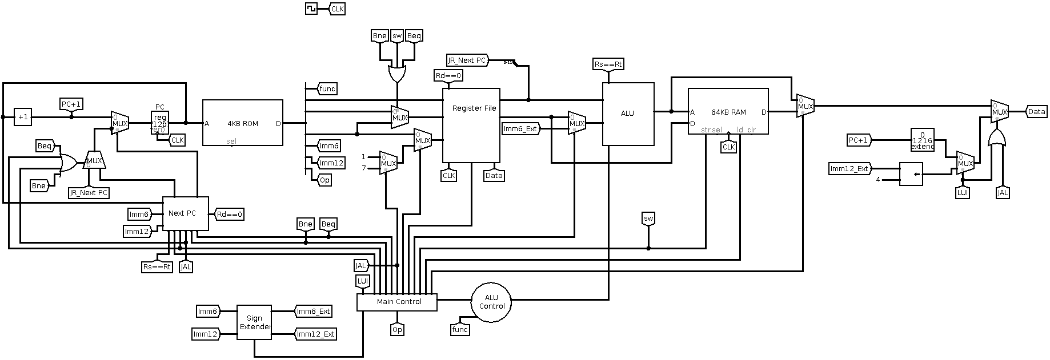

2 – ALU :
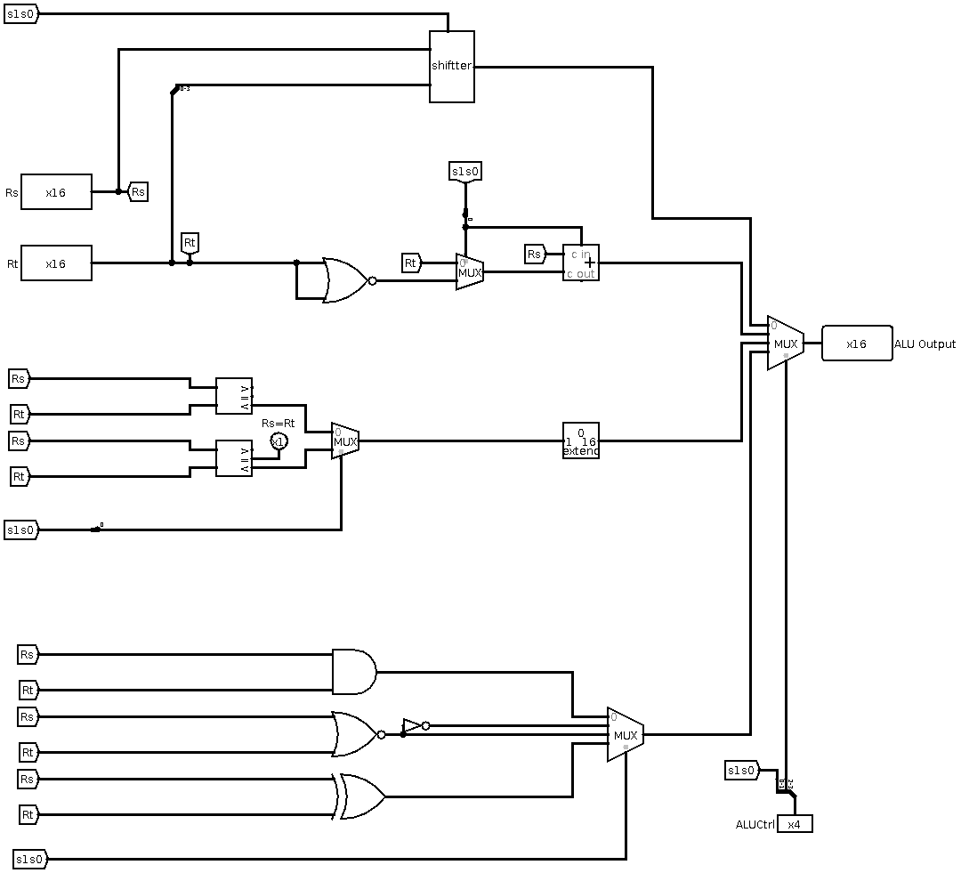

10 – Main Control :
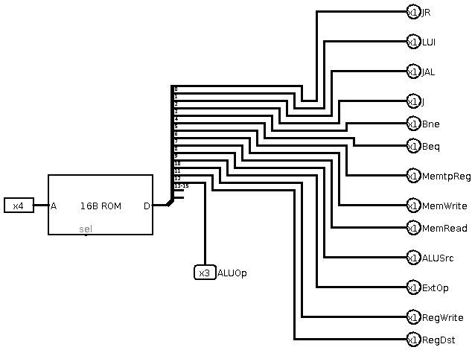

9 – ALU Control :
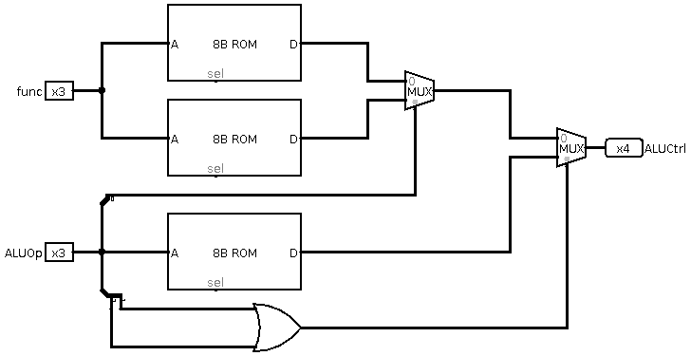

3 – Register File :
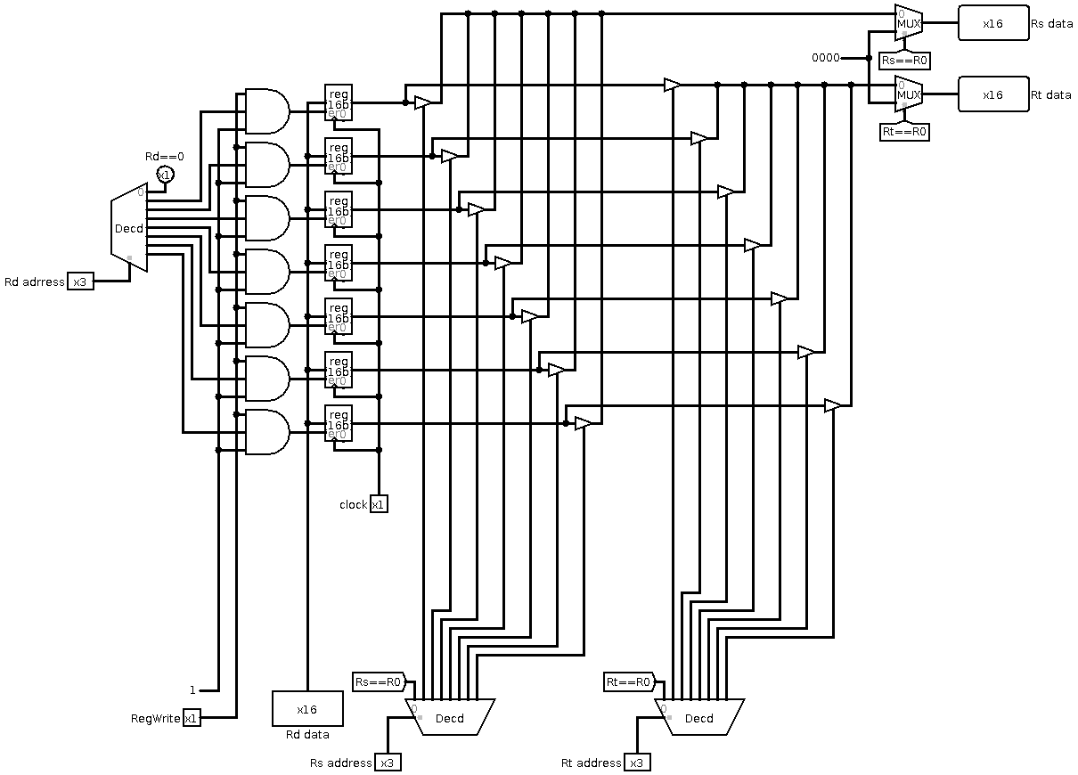

4 – Next PC :
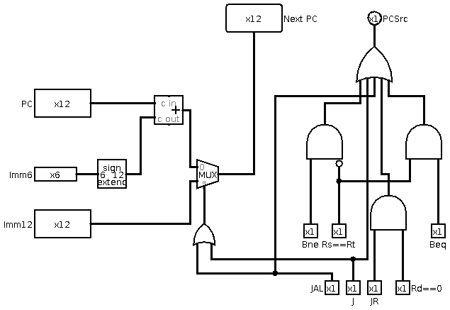
5 – Shiffter :
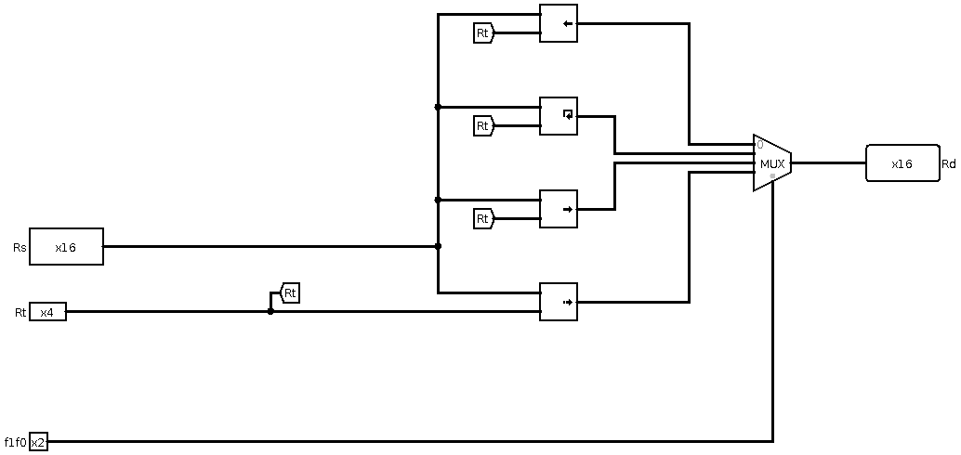

6 – Sign Extender :
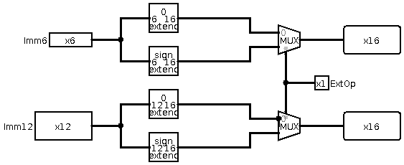
7 – Splitter :
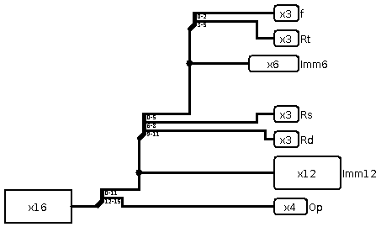

8 – Incrementer :
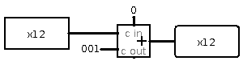

Control Signal :

Provide a complete description of the control logic and the control signals. Provide a
table giving the control signal values for each instruction. Provide the logic equations for
each control signal.

Provide a complete description of the forwarding logic, the cases that were handled, and
the cases that stall the pipeline, and the logic that you have implemented to stall the
pipeline.
Provide list of sources for any parts of your design that are not entirely yours (if any).
Carry out the design and implementation with the following aspects in mind:
- Correctness of the individual components
- Correctness of the overall design when wiring the components together
- Completeness: all instructions were implemented properly, detecting dependences
and forwarding was handled properly, and stalling the pipeline was handled properly
for all cases.

Simulation and Testing
Carry out the simulation of the processor developed using Logisim.
Describe all the features of the simulator used for simulating your design with a clear
emphasis on its advantages and limitations (if any) for simulating the design, list the
known bugs or missing features (if any).
Describe the test programs that you used to test your design with enough comments
describing the program, its inputs, and its expected output. List all the instructions that
were tested and work correctly. List all the instructions that do not run properly.
Describe all the cases that you handled involving dependences between instructions,
forwarding cases, and cases that stall the pipeline.
Also provide snapshots of the Simulator window with your test program loaded and
showing the simulation output results.

Teamwork
Two or at most three students can form a group. Make sure to write the names of all the
group members on the project report title page.
Group members are required to coordinate the work equally among themselves so that
everyone is involved in all the following activities:
- Design and Implementation
- Simulation and Testing
Clearly show the work done by each group member using a chart and prepare an
execution plan showing the time frame for completing the subtasks of the project. You
can also mention how many meetings were conducted between the group members to
discuss the design, implementation, and testing.

